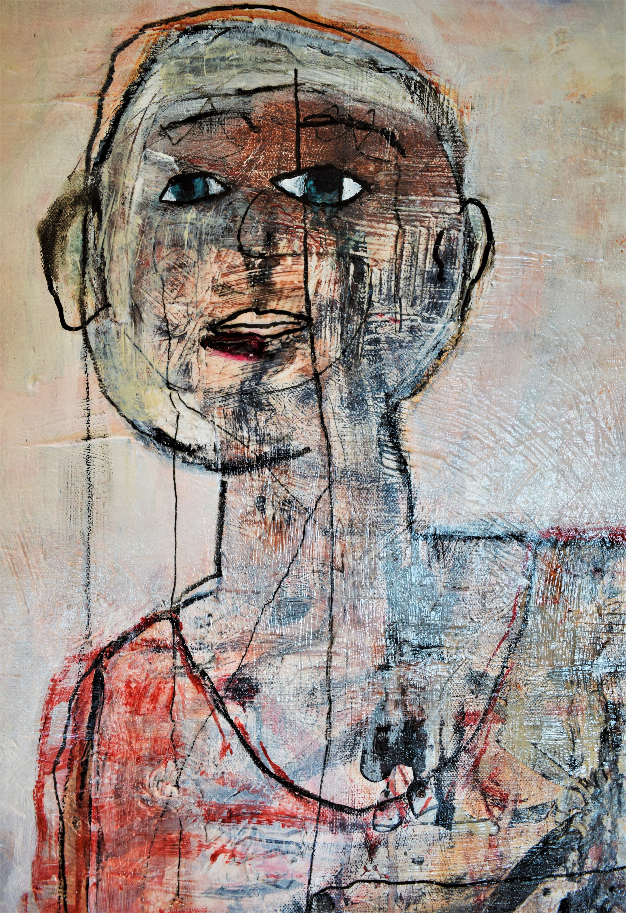  Me Through Your Eyes  Paintings About Autism  Me Through Your Eyes is a figurative painting series by Jenny Snyder, portraying the experience of people who have disabilities such as autism. The images are meant to reflect the stillness and complexity of the inner life, as well as the experience many disabled individuals have of stigma and difference. She incorporates many materials into her art, including oil and acrylic paints, local clay pigments, walnut oil, imported pigments and historic canvases. Constructed of hidden mazes, Jenny’s figures are intended to be like paths of travel that connect us to other people. She explores the themes of social isolation and awkwardness with humor and tenderness, trying to illuminate the world of relationships. | Jenny Snyder is a painter and disability rights activist, who worked for many years in San Francisco within the homeless shelter system. She paints about autism and she paints her dreams, reaching into her life experiences to shape images that tell stories. Many of her paintings originate in her work within the disability civil rights movement. She lives near Tahoe, California with her husband Chuck and dog Max, where she enjoys yoga, hiking, and spending time in her yard with the bees.  RambleFish Arts:  Art by Jenny  Grass Valley, California  (415)271-7763  Webpage:  Facebook:  email: navestown@gmail.com  These paintings are available.

